Table of Contents

Grade 9

1. Introduction
2. Projects
   1. Science Projects
      1. Creating a 3D Model of a Plant
      2. Energy Production Video
   2. Tech Projects
      1. Windmill Project
      2. Solar Boat Project
   3. Academic Achievement
3. Extracurricular Involvement
   1. Non-SciTech Extracurricular
   2. SciTech Extracurricular
4. Figures/Evidence

Grade 9. Portfolio

**1. Introduction**

Hello my name is Owen Brake. I am currently enrolled in this school Port Credit Secondary School and I am in grade 9. I am currently taking Tech, Phys.Ed, English and Visual Art in my first semester. With Math, French, Science and Geography in the second semester. I have done fairly well in my classes and I have been improving through every report card. I am interested in Computer Science and Physics.

I took SciTech for the academic challenge and opportunities it would provide. The reason the program interested me was because it focused on my two favourite subject of Science and Technology. Throughout middle school I had be interested in and done well in Science and Math and I required more challenge than from my middle school Allan A Martin so I looked for a school where I could be more challenged. I was also intrigued by the potential learning experiences that it would give me to help through my post-secondary education. During my middle school education I started to learn programming in different languages. First Visual Basic (VS) then I moved onto java and am currently working with C#. I have created countless numbers of applications and games but many have been replaced for my current projects. My main applications have been Donkey Kong on VS, a dungeon hack and slash in Java and countless projects in C# from a First Person Shooter with continuously spawning enemies to text editors with save and open, calculators with cos, sin and tan. However my main achievement was an arcade machine I built in my basement. I used an old monitor and I bought the raspberry pi model B worth $25 and I built an arcade machine. I used a wood saw to cut long strips of black covered wood and used diagrams from the internet to create the shell. After I hooked up arcade buttons to the GPIO pins that were numbered. However the tough part was the software getting 2 players to work with a GPIO and software only made for one player was tough. I had to edit the code by learning python to try and change the code to allow 2 players. I spent countless hours but I loved it and thought I should go to Port Credit since they have a program that would allow me to do this and learn and practice.

For my post-secondary education I plan to go to university. I plan to take courses in computer science or software engineering. I have been looking into universities like Waterloo or U of T which have good computer science programs. If I were to go to waterloo I would participate in the great co-op programs which would provide me with great opportunities to find work after university. After university I would try to find any job in computer programming I would probably find a job developing windows or mobile applications. I most likely would find a job in downtown Toronto creating enterprise applications for companies.

**2. Projects**

*Science Projects*

Plant Project (Figure 1.)

The Plant Project was a very interesting project, it made me pay close attention to all the specific adaptions that plants develop. This project taught me so much about the Tobacco plant and all of its features. I built my tobacco plant out of green/brown tissue paper, green construction paper, green wire, markers and a long plastic dowel. I learned how different plants adapt based on their surroundings from the size of the leaves to the chemical compound created for defense. It also made me pay attention to the exact details of the structure and how the plant works it taught me about how the plant grows and how it reproduces. I put a lot of time and effort in to this project and it paid off. I got a 90% which significantly increased my average. It also taught me a lot of things that would be extremely beneficial for the future tests and exams I would write. If there was anything I could change is I would have spent more time memorizing my script and including more information.

Energy Production Video (Figure 2.)

This project was my favourite project of the year. This project was also a very creative one. The project was to design a video of any kind about some sort of energy source that was chosen for us and present in front of the class. The whole point of the project was to teach us the advantages and disadvantages for each energy source and which would be best for the future of the world. The project definitely shed a light on the problems of our current way of generating energy and how we can improve on them for the future.

I worked with Joseph Stephen and Richard Fan on this project who both helped greatly. We made a “Planet Earth” style documentary on wind energy. I was inspired especially on the Planet Earth Africa where there is a calm soothing voice over intense scenes. We used my microphone and my laptop to record the audio and royalty free videos from the internet to showcase the pros and cons of wind energy. I learned a lot of things from that project, I learned how wind turbines work and how they benefit/detriment communities. It also significantly helped me on the unit test where we had to answer questions on our energy project. Since I worked very hard on the energy project I did very well on it. I feel that we did a fantastic job on the project we spend a lot of time and effort planning and recording this project on our own time. Our hard work payed off too I got a 23/24 or just under 96%. Overall I am satisfied with the idea and final product of our project and the learning experiences it provided me. However if there was anything I could change is I would have included more real life footage to give a more authentic view.

*Tech Projects*

Windmill Project (Figure 3.)

The windmill project was our second project. I worked with Ahmed Imran and Joseph Stephen. Our objective was to design and create a windmill or a watermill that is the most efficient. Most of the tools and materials we needed were provided. This was a very interesting project because there were so many things we had to account for. The weight of the blades/rotors, the material of the rotors, height of rotors and the stand also the amount of gears. This all had to be accounted for and it was a tough battle. We used a new design that is called the vertical windmill. It is a new design that is being tested and supposed to be more efficient in the long term compared to the standard design. We built the rotors out of PVC pipe connected by wood. We built the stand out of wood and hot glued everything together. Our windmill did fairly well in the contest we had a windmill that rotated consistently. If there was anything I could change I would have used a lighter weight material for the rotors and stabilized the stand better.

Solar Boat Project (Figure 4.)

The solar boat project was our culminating for Tech worth 30% of our mark. The whole point was to design a boat that could balance perfectly with a solar panel, have a light weight, and have a perfectly positioned motor to push it forward at the maximum power. We were provided pink foam, a motor and axle, and a solar panel with wires. I cut my boat into the smallest size possible with a sharp and sanded down the hull. I rotated the axle at about a 65o angle vertically. To create a blend of forward force and power. I was inspired by speed boats where they have a thin narrow form that moves very quickly in the water. I was also inspired by the canoe which has a similar hull to my boat.

**3. Extracurricular**

Non-SciTech Extracurricular (Figure 12,13)

In the first semester I joined cross country. It was a very interesting experience. Cross country was very memorable since it was my first extracurricular experience with Port Credit. It was an experience I had never experienced going to different places like running up the hills at Centennial Park to running by the beautiful lake at Heart Lake ROPSAA. I will never forget this experience that taught me important life skills like responsibility and learning the importance of improvement and excellence above all else.

Volunteer

Also however outside of school I have been teaching baseball for an organization called Batters up Baseball at Queenstown Drive Public school. I worked in the winter and we taught children 5-13 years old how to play baseball. It provided me a great experience where I learned to work with kids and how to be a leader. I worked with Jeffery Buloch and we got our volunteer hours there. I volunteered for 10 hours in the winter program where I specialized teaching how to throw and catch with the children 5-9. Overall this experience taught me a lot and showed me how to be control and be a leader.

SciTech Extracurricular (Figure 5-11)

In my second semester I participated in a challenge known as Noggin Hoggin. It was a challenge where every day there was a new challenge and you had to answer them every day or you would be eliminated. 6 days, 6 challenges was the slogan. The challenge was very hard and we were given 24 hours to answer a question. However on the last day if you got the answer wrong you were eliminated and you would be put on the leaderboard. We had to use google to try and find answers to really obscure questions. Most of my entire science class participated and we competed for the right answer. I answered all the questions until the last day where I got the wrong answered and failed. I got one answer right however I could have gotten the second one except for a spelling error on a website. But Noggin Hoggin taught me a lot of problem solving mechanics and taught me how to search effectively.

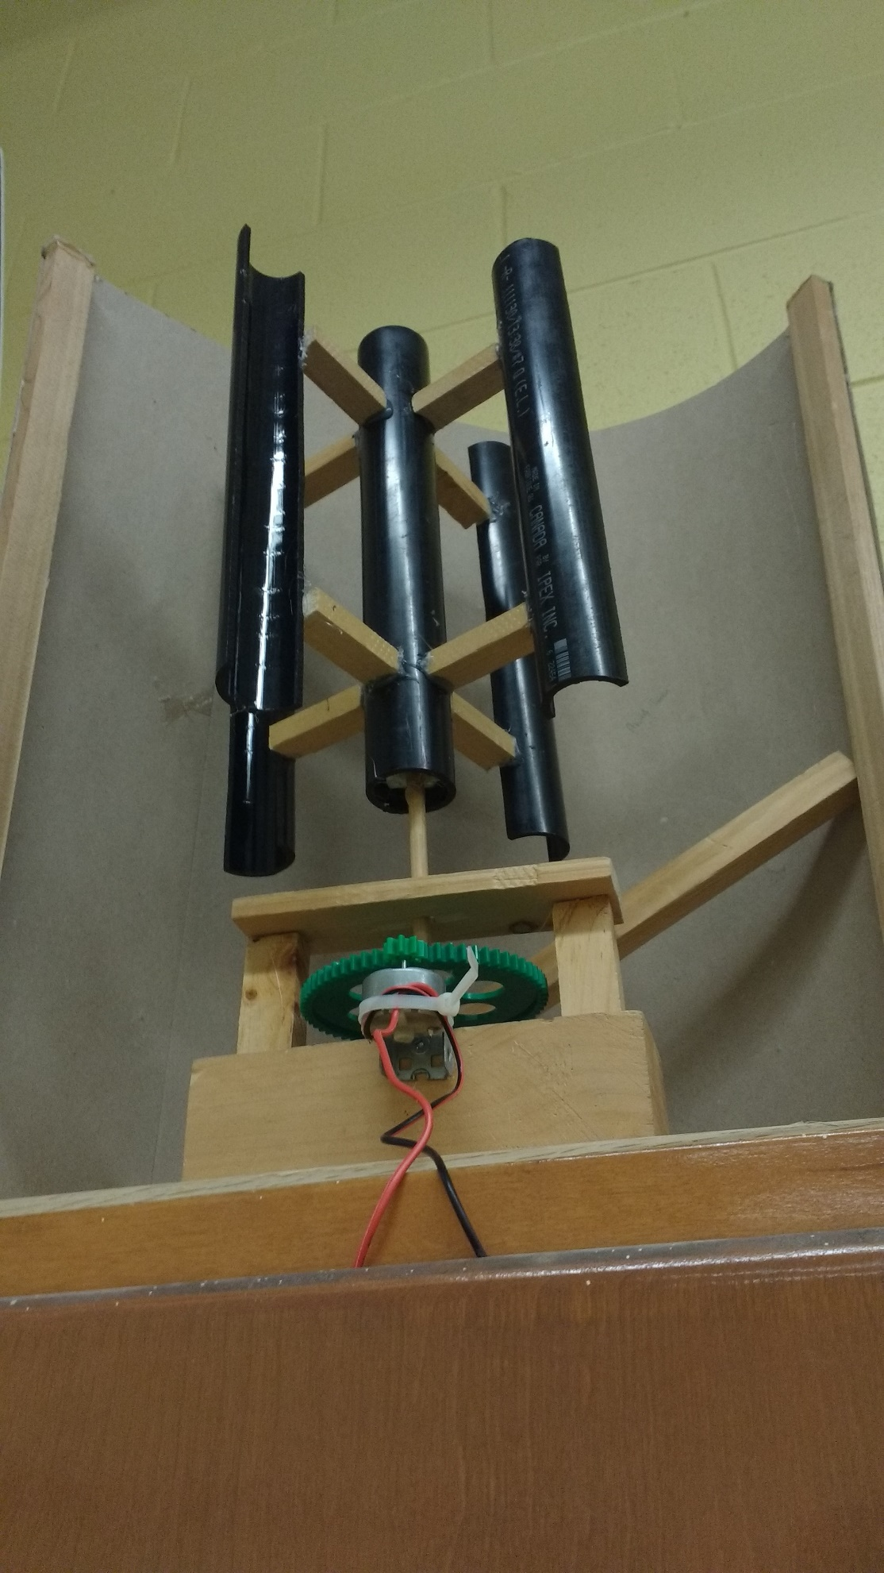

Figure 3.

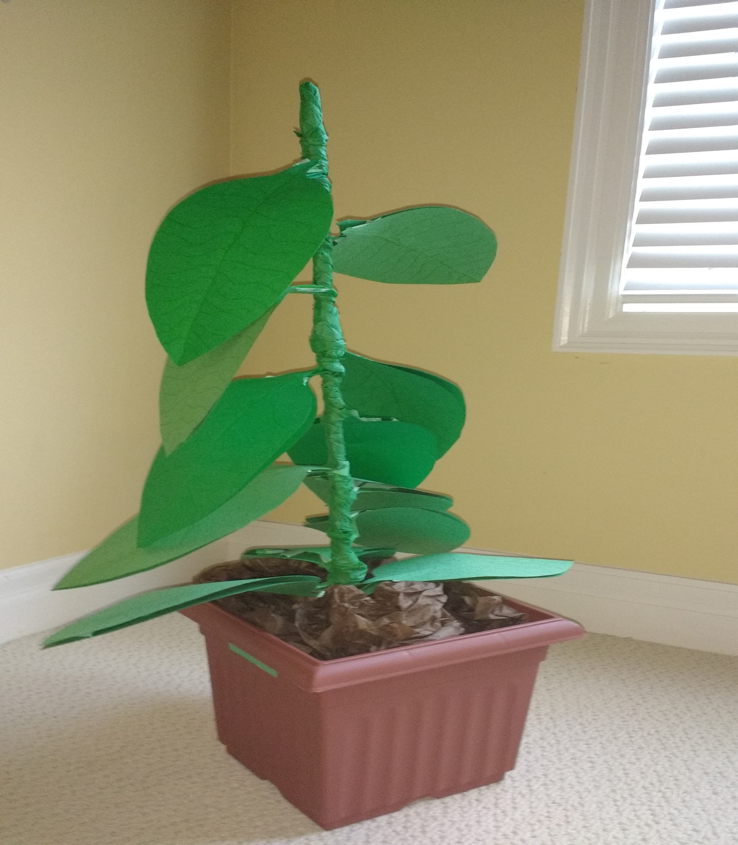

Figure 1.

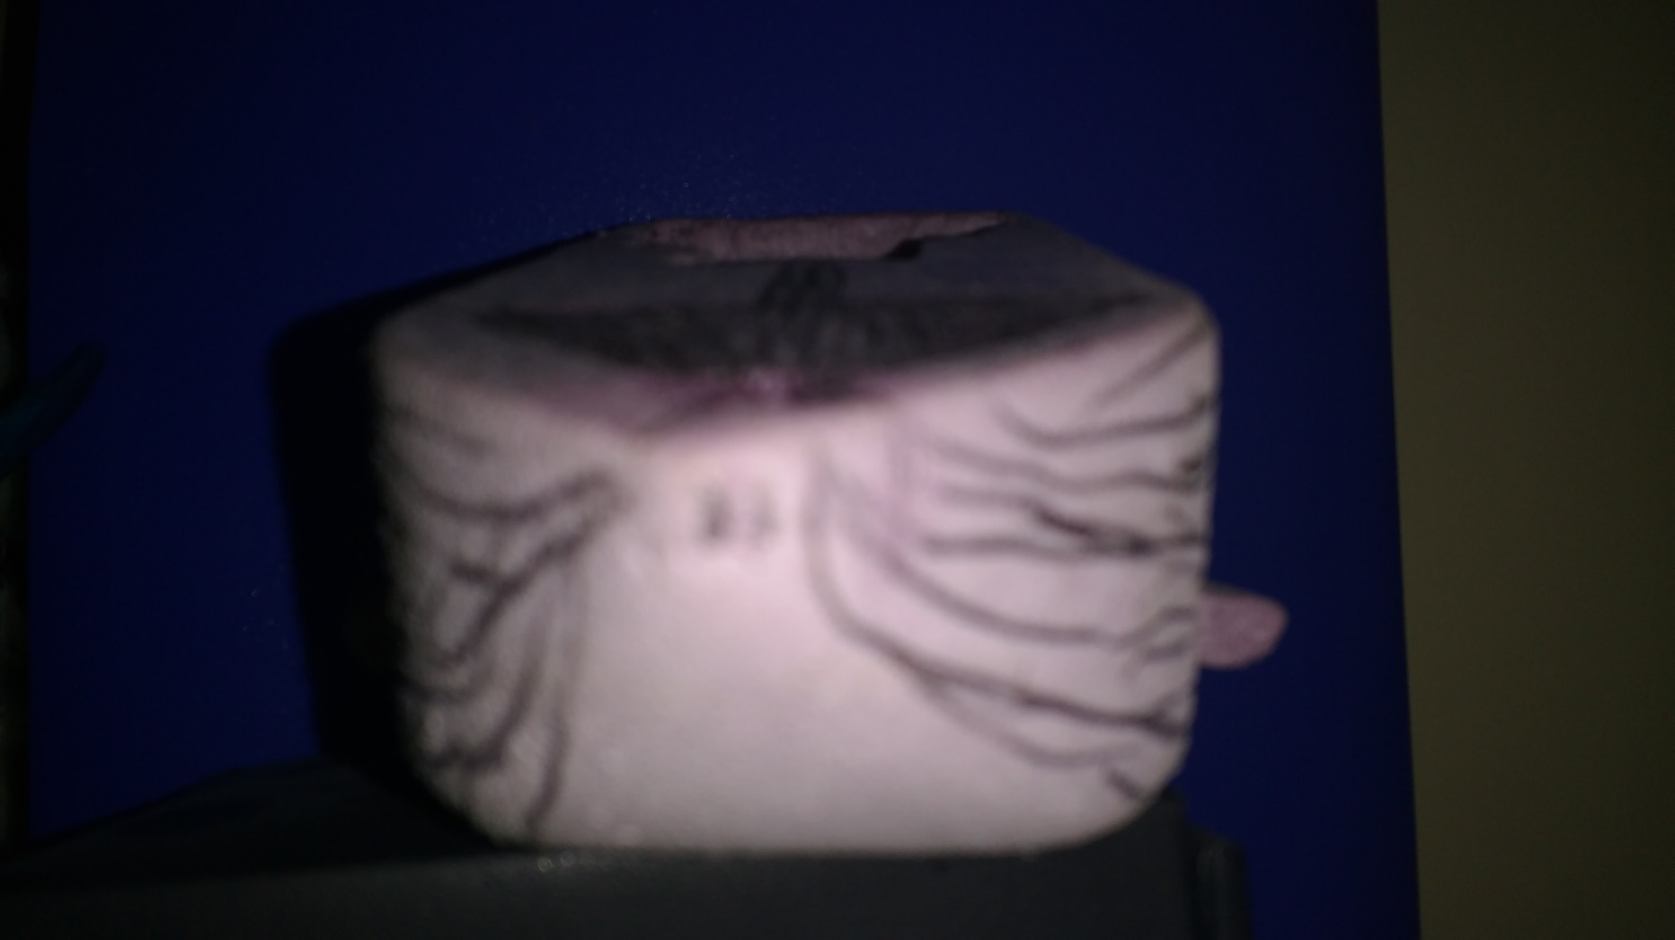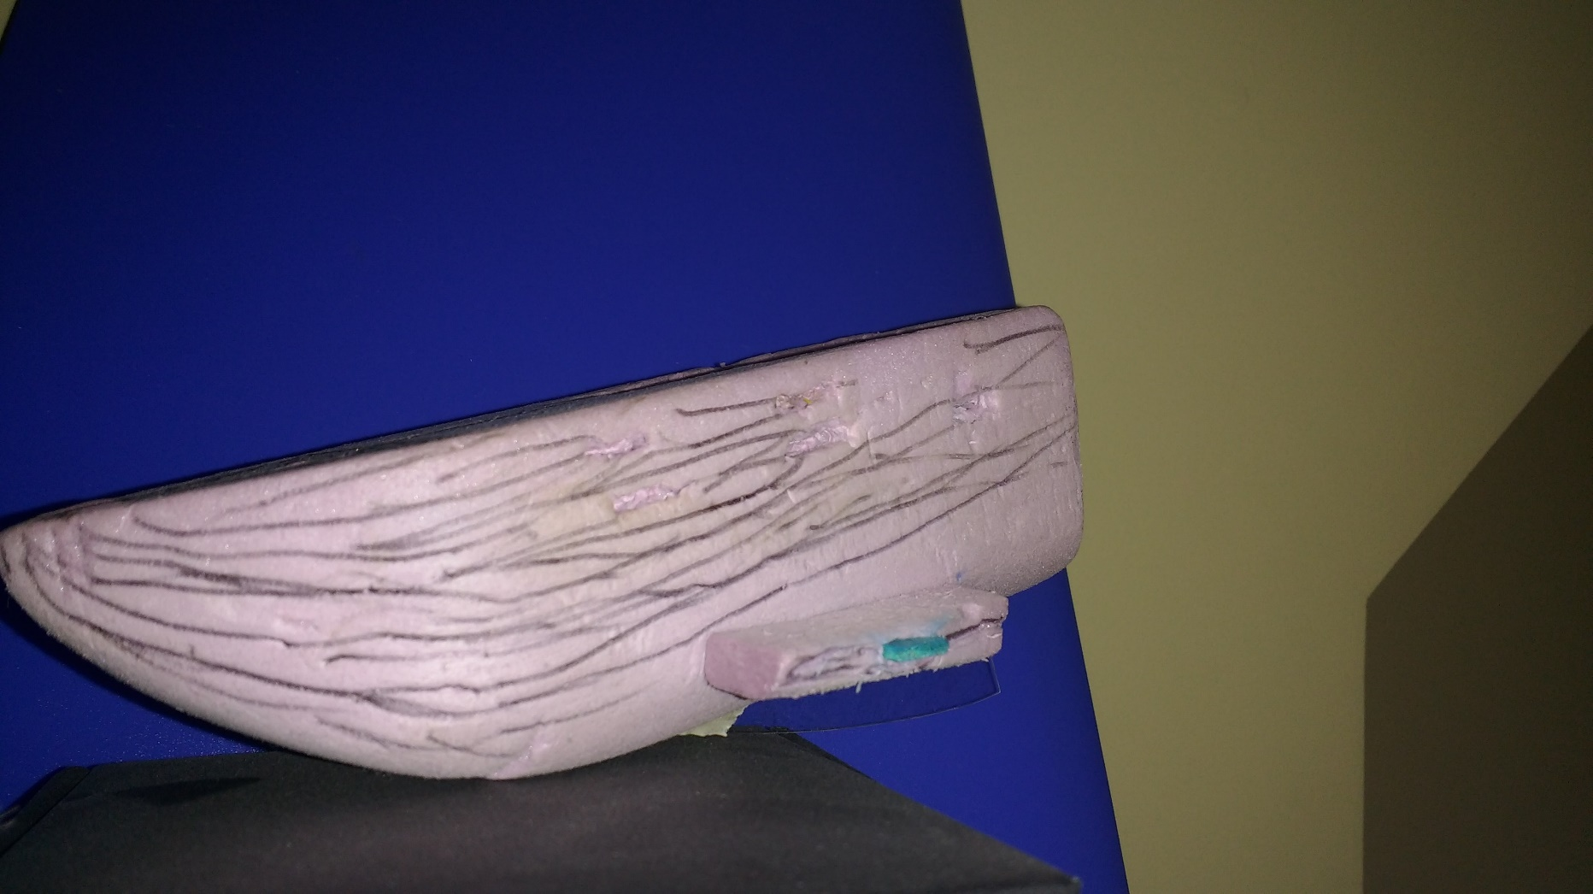

Figure 4.